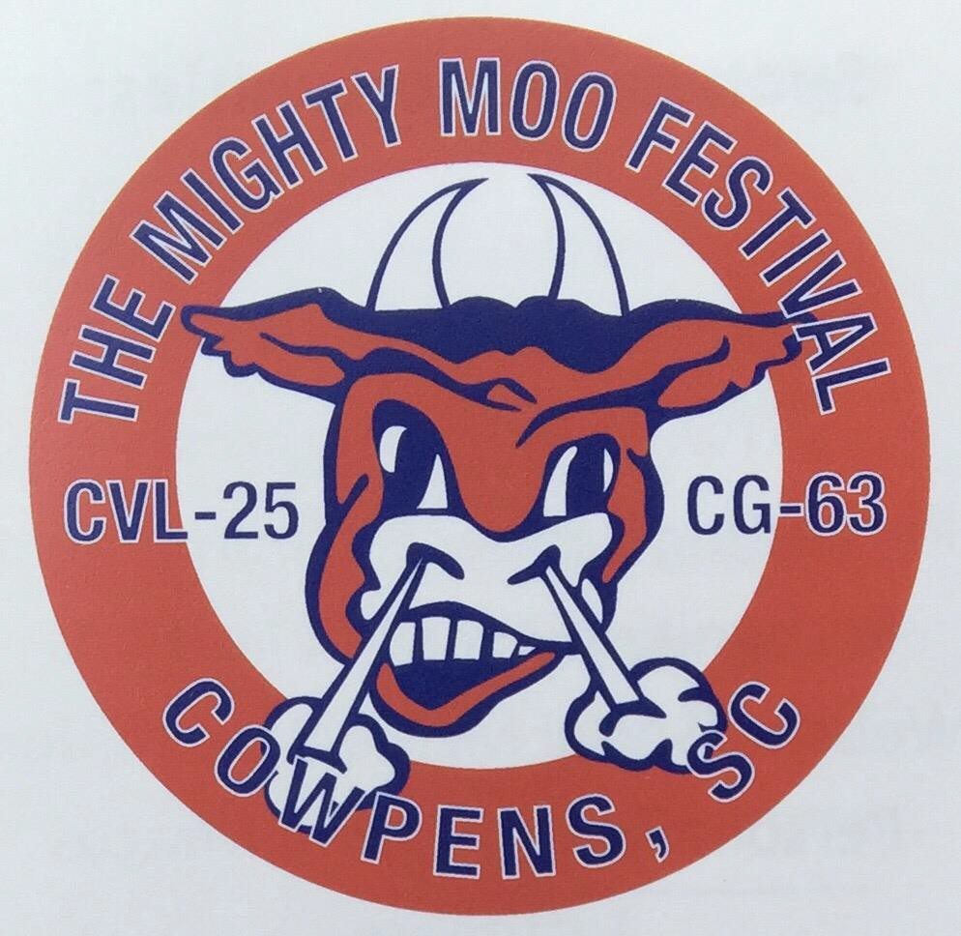

24th ANNUAL
MIGHTY MOO GOLF TOURNAMENT
Benefiting

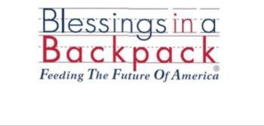
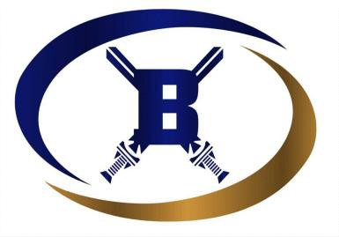
Broome H.S. Scholarship
Friday, June 17th The Creek Golf Club Check-in at 9:00am
Shotgun start 10:00am
------------------------------
Sponsor Opportunities
$1,000 Corporate Sponsor- One 4 man team. -Banner at tournament. - Website/Social Media recognition.

$350 Food/Beverage Sponsor- Sign on beverage carts.
Website/Social Media recognition.

$150 Hole Sponsor Sign on hole. - Website/Social Media recognition.
-----------------------------
Captain’s Choice
Format
4-person team $280
-Lunch Provided
-Cart/Green Fee
-Door Prizes
-Hole-in-one prizes Provided by Gaffney Buick GMC
------------------------------
For more information call:
Travis Linder 864-706-1165
or Derrick Foster 864-809-0659

